**Kandis’ Christmas List**

**Stocking Stuffers**

* Scratch tickets
* Brown hair elastics (no metal) ouchless
* 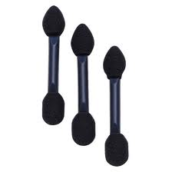Brown bobbie pins
* Eye shadow applicators
* Cover girl espresso eye liner
* Gum
* Candy
* Deodorant – Degree (Linen Dry)
* Victoria Secret Love spell perfume
* Toothbrush (soft)
* Floss
* Small hand sanitizer (for smock at work)
* Small hand lotion (for smock at work)

**Other Ideas**

* Victoria Secret thong underwear (small)
* Rondo or Celtics hard case for my cell phone
* Brown socks for work- Kohls has them in sets of 3
* Knee high socks from Target- I like designs on them not plain
* Small silver earrings
* **ISO Beauty 1/2" Twister Curling Iron – Black (Target)**

**http://www.target.com/p/iso-beauty-1-2-twister-curling-iron-black/-/A-13522219#prodSlot=medium_2_15**